Sinh Viên : Vũ Văn Trọng

Mã số sinh viên : 20184206

ASSIGNMENT 2

.eqv MONITOR_SCREEN 0x10010000 #Dia chi bat dau cua bo nho man hinh

.eqv RED 0x00FF0000 #Cac gia tri mau thuong su dung

.eqv GREEN 0x0000FF00

.eqv BLUE 0x000000FF

.eqv WHITE 0x00FFFFFF

.eqv YELLOW 0x00FFFF00

.text

li $k0, MONITOR_SCREEN #Nap dia chi bat dau cua man hinh

li $t0, RED

sw $t0, 0($k0)

nop

li $t0, GREEN

sw $t0, 4($k0)

nop

li $t0, BLUE

sw $t0, 8($k0)

nop

li $t0, WHITE

sw $t0, 12($k0)

nop

li $t0, YELLOW

sw $t0, 32($k0)

nop

li $t0, WHITE

lb $t0, 42($k0)

nop

* Text Segment:

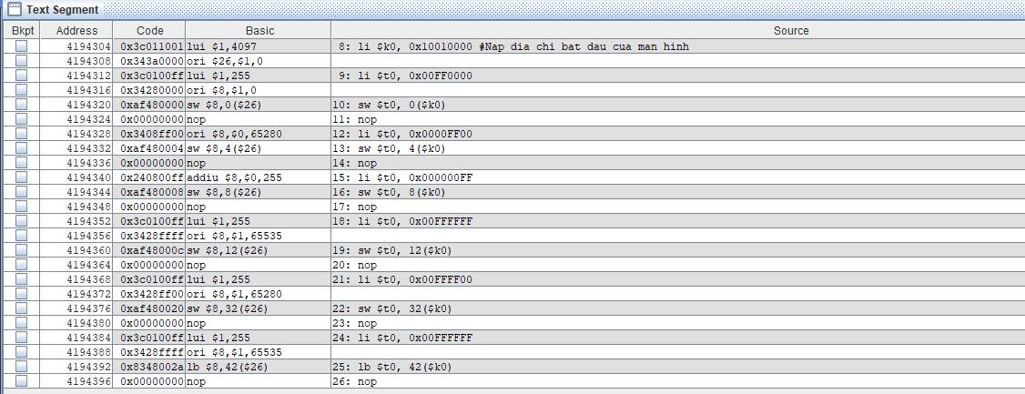

* Kết quả

